**CHAPTER-5 Class Room Objective**

**MIRROR-IMAGES**

**Mirror-Image:**The image of the object, as seen in a mirror, is called its mirror reflection or mirror image.

In such an image, the right side of the object appears on the left side and vice-versa. A mirror image is therefore said to be laterally inverted and the phenomenon is called Lateral Inversion.

**MIRROR-IMAGES OF THE CAPITAL LETTERS**

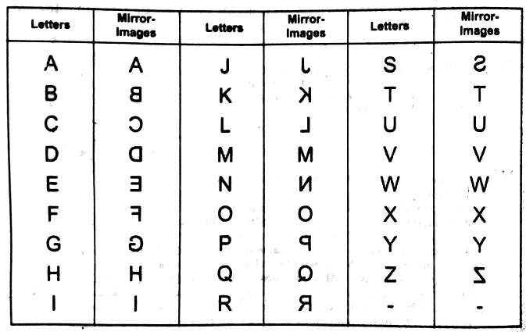

**Remarks:** The letters which have their mirror images identical to the letters itself are:

**A, H, I, M, O, T, U, W, X, Y**

**Examples:**Mirror-images of certain words are given below:

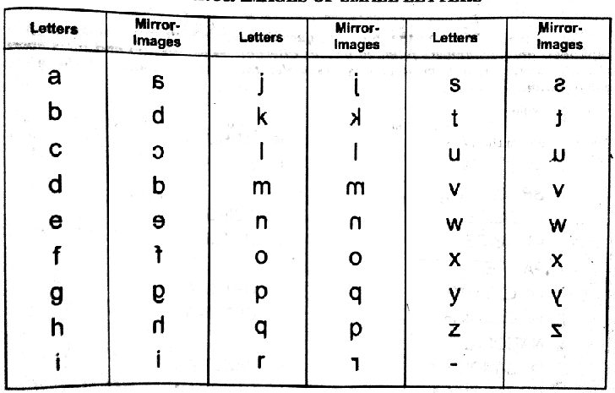

**Examples;** Mirror-image of certain words are given below;

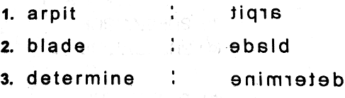

**MIRROR-IMAGE OF NUMBERS**

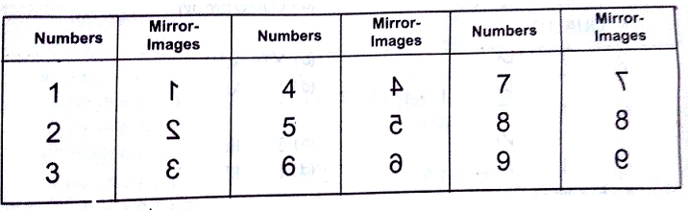

**Examples:**  Mirror-Images of certain combinations of alphabets and numbers are given below:

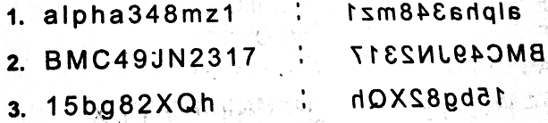

**WATER-IMAGES OF CLOCKS**

There are certain questions in which the positions of the hour-hand and the minute hand of a clock as seen in a water are given. On the basis of the time indicated by the water image of the clock we have to detect the actual time in the clock. In the solution of such questions we use the fact that if an object A is water image of another object B then B is the water image of A. The method of solving such questions would be clear from the following examples.

**Ex1.** Looking into the mirror, the clock shows 9:30 as the time. The actual time is

a) **2:30** b) 3:30 c) 4:30 d) 6:30

**Ex2.** When seen through a mirror, a clock shows 8:30. The correct time is

a) 2:30 b) **3:30** c) 6:00 d) 5:30

**Ex3.** By looking in a mirror, it appears that it is 6:30 in the clock. What is the real time?

a) 6:30 b) **5:30** c) 4:30 d) 6:30

**Ex4.** A clock seen through a mirror shows quarter past three. What is the correct time shown by the clock?

a) 9:45 b) 9:15 c) **8:45** d) 3:15

**Ex5.** A clock seen through a mirror shows quarter to three. What is the correct time shown by the clock?

a) 8:15 b) 9:12 c) 8:17 d) **9:15**

|  |
| --- |
| **EXCERCISE** |

**Directions**: In each of the following questions, you are given a combination of alphabets and/or numbers followed by four alternatives a), b), c) & d). Choose the alternative which most closely resembles the mirror image of the given combination.

**Q1.** FIXING



**Q2.** MALAYALAM



**Q3. 247596**



**Q4.** q utubgarh



**Q5.** Nu56p7uR



**Q6.** TERMINATE

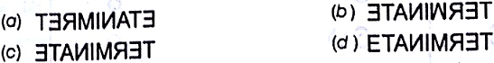

**Q7.** QUALITY

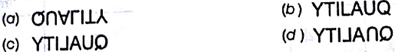

**Q8.** WHITE



**Q9. BRISK**



**Q10. NATIONAL**



**Q11.** Question figure

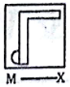

Answer figure

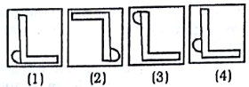

**Q12.** Question figure

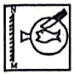

Answer figure

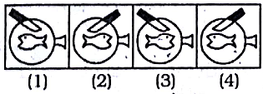

**Q13.** Question figure

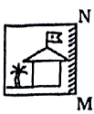

Answer figure

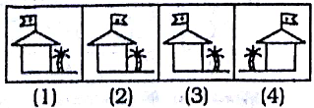

**Q14.** Question figure

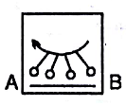

Answer figure

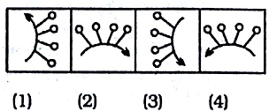

**Q15.** Question figure

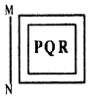

Answer figure

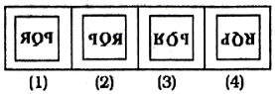

**Q16.** Question figure

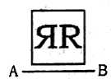

Answer figure

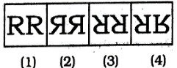

**Q17.** Question figure

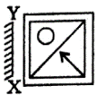

Answer figure

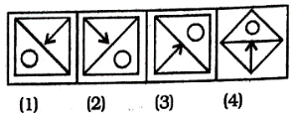

**Q18**. Question figure

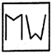

Answer figure

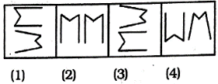

**Q19.** Question figure

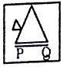

Answer figure

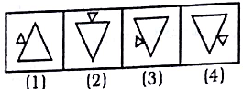

**Q20.** Question figure

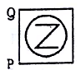

Answer figure



